# Project Design Phase-II

**Data Flow Diagram & User Stories**

|  |  |
| --- | --- |
| Date | 10 October 2022 |
| Team ID | PNT2022TMID39129 |
| Project Name | A Novel Method for HandwrittenDigit  Recognition System |
| Maximum Marks | 4 Marks |

**Data Flow Diagrams:**

A Data Flow Diagram (DFD) is a traditional visual representation of the information flows within a system. A neat and clear DFD can depict the right amount of the system requirement graphically. It shows how data enters and leaves the system, what changes the information, and where data is stored.

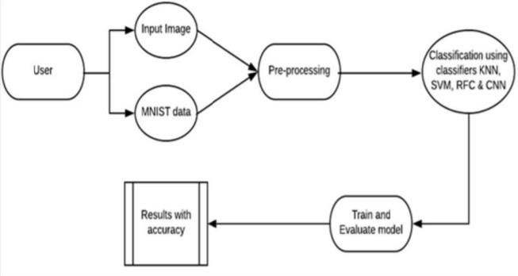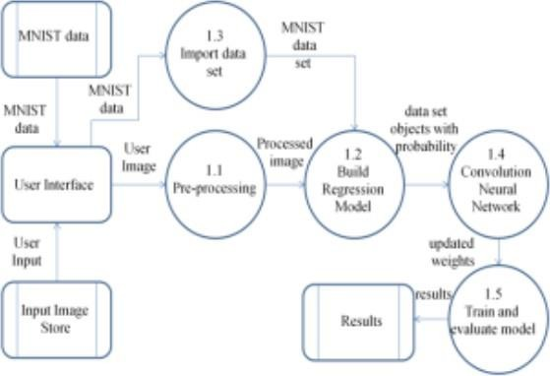**Example:** [**(Simplified)**](https://developer.ibm.com/patterns/visualize-unstructured-text/) **FLOW**

# User Stories

Use the below template to list all the user stories for the product.

|  |  |  |  |  |  |  |
| --- | --- | --- | --- | --- | --- | --- |
| **User Type** | **Functional**  **Requireme nt (Epic)** | **User**  **Story Number** | **User Story / Task** | **Acceptance criteria** | **Priority** | **Release** |
| Customer (Mobile user) | Registration | USN-1 | As a user, I can register for the application by entering my email, password, and confirming my password. | I can access my account / dashboard | High | Sprint-1 |
|  |  | USN-2 | As a user, I will receive confirmation email once I have registered for the application. | I can receive confirmation email & click confirm | High | Sprint-1 |
|  |  | USN-3 | As as user, I can view the guide and awareness to use this application. | I can view the awareness to use this application by a  practical method. | Low | Sprint-2 |
|  |  | USN-4 | As a user, I can read the instructions to use this application. | I can read instructions to use it in user-friendly  method. | Medium | Sprint-1 |
|  | Login | USN-5 | As a user, I can log into the application by entering email & password | I can enter the application | High | Sprint-1 |
|  | About | USN-6 | I can click on the “About “ to get the idea of a handwritten digit recognition tool for recognition of digits. | I can get an idea about the project | Low | Sprint-1 |
| Customer (Web user) | Predict | USN-7 | As a user I can upload my handwritten digits images to be recognised from the computer. | I can choose any image from my device | High | Sprint-2 |

|  |  |  |  |  |  |  |
| --- | --- | --- | --- | --- | --- | --- |
| **User Type** | **Functional**  **Requireme nt (Epic)** | **User**  **Story Number** | **User Story / Task** | **Acceptance criteria** | **Priority** | **Release** |
| Customer Care Executive |  | USN-8 | As a user I will train and test the input to get the maximum accuracy of output | I can able to train and test the application until it gets maximum accuracy of the  result. | High | Sprint-4 |
| Administrator | Launch | USN-9 | As a user, I can upload my handwritten digit images to be recognised from the computer. | I can choose and upload the image from the system storage and also in any  virtual storage. | Medium | Sprint-3 |
|  |  | USN-10 | I can scan one page at once. | I can get the recognised digits from the input  given. | High | Sprint-4 |
|  | Recognize | USN-11 | As a user I can turn on the camera using the input button. | I can get the input to be digitized. | High | Sprint-3 |
|  |  | USN-12 | As a user , I can use the web application virtually anywhere. | I can use the application portably anywhere. | High | Sprint-1 |
|  |  | USN-13 | As it is open source,i can use it cost freely. | I can use it without any payment to be paid for it to access. | Medium | Sprint-2 |